Enhancing Situation Awareness and Trust in Real-Time Systems through the Application of Visual XAI:
Research Proposal

Ohad Orbach

1. Introduction 3
2. Background 5
3. Related work 10
4. Research Topic and Questions 14
5. Framework Design: 15
6. Tools and Methods 18
7. Research Plan 27
8. Initial Results 28
9. Research Contribution 29
10. Reference 30

Introduction
In today's technologically driven landscape, sectors from healthcare to transportation heavily rely on technology (Dwivedi et al., 2023). At the heart of this shift are real-time systems, which make swift decisions, often bypassing human involvement. These rapid decisions are made by Artificial Intelligence (AI) (Arrieta et al., 2020). While AI has amplified the capabilities of these systems, it also made them more complex. For many users, understanding the decision-making has become a challenge, likening these systems to a "black box" (Guidotti et al., 2018). Such lack of clarity isn't only an academic problem, it can have real-world implications. For instance, consider a healthcare AI making a diagnostic decision or an autonomous vehicle's swift movement decision. In a world where AI is growing rapidly, making real-time systems work better isn't just about making things faster or smarter. It's about businesses saving money and giving people a better and safer experience.
A critical consideration is situational awareness, essentially understanding the dynamic environment around oneself. This understanding is vital when working with real-time systems (Endsley & Kiris, 1995; Laato et al., 2022). Good situational awareness can be the difference between success and catastrophe, especially in critical situations (Rees & Müller, 2022).
Trust is another pivotal aspect. The "black box" nature of many AI systems can foster uncertainty (Guidotti et al., 2018; von Eschenbach, 2021). If users distrust the AI, they might dismiss its suggestions or doubt its capabilities (Shneiderman, 2020). For example, a skeptical doctor might overlook an AI tool's advice, risking misdiagnoses (Bussone et al., 2015).
Here, the role of eXplainable AI (XAI) becomes crucial. XAI aims to boost understanding, trustworthiness, transparency, control, and fairness of AI systems (Laato et al., 2022). It generally approaches the challenge in two ways (Arrieta et al., 2020; Laato et al., 2022; Ali et al., 2023):
- By designing simpler models, known as white/grey box models, that are inherently comprehensible.
- By adding explanations to complex "black box" models, often associated with advanced Machine Learning (ML) models or Deep Neural Networks (DNN’s).
Given the challenges described above, XAI emerges as a promising solution, offering clear and interpretable explanations for AI's decisions, bridging the gap between users and complex AI models (Langer et al., 2021; Guidotti et al., 2018). Visual explanations, drawn from the field of Information Visualization, enhance understanding by displaying data visually (Ware, 2019). Tailored visualizations clarify AI decisions, offering insights and making the decision-making process more intuitive (Fjeld et al., 2020; Kawakura et al., 2022). In real-time systems, these visual explanations are vital, enabling prompt insights and facilitating speedy decisions (Hudon et al., 2021; Schrills & Franke, 2020).
This research focusses on two main questions:
1. First, we want to understand how information visualization can affect people in an AI system. 2. Second, we're curious about how these visualizations can help people understand what the AI is doing and be more aware of how it works.
The expected outcome of the study is a generic framework for assessing users' trust in AI- based real-time decision-making system using visualizations that will be evaluated in a realistic cas4e study by users.

Background
  - AI in real time systems
A real-time system is a system that must satisfy explicit (bounded) response-time constraints or risk severe consequences, including failure (Laplante, 2004). The first real-time system was created for military use. Back in 1947, IBM developed a flight simulator named project Whirlwind for the U.S. Navy. In the 1950s, they designed an air defence system called project SAGE for the U.S. Air Force. By the 1960s, NASA was using real-time systems for space projects, such as Project Mercury and Project Apollo. After that decade, these real-time systems weren't exclusive to the military anymore, they began popping up in areas like healthcare, finance, and security. Initially, these systems operated based on specific rules (Laplante, 2004). But, as tasks became more intricate and the volume of data expanded, the limitations of these rule-based systems became clear.
Artificial Intelligence (AI), as we know it today, traces its roots back to the 1950s, starting with the Dartmouth Conference. This event set the stage for AI's evolution, focusing on challenges like problem-solving and natural language processing (NLP). The 1960s witnessed significant advancements with notable programs like GPS and ELIZA. The introduction of Intel's first microprocessor in the 1970s marked a significant leap in AI development. The 1980s and 1990s saw progress in computer vision and NLP, while the 2000s ushered in the era of big data. The continuous advancement in processing power and algorithms has seamlessly integrated AI into real-time systems, making it an integral part of modern technology and daily life (Russell & Norvig, 2010)
With AI, these systems could learn from data, adjust, and make decisions that might be better than those from preset rules. AI started to play a pivotal role in real-time decisions, opening new possibilities and challenges in multiple sectors (Arrieta et al., 2020). While the integration of AI into real-time systems made them more powerful by offering adaptability and the ability to handle vast amounts of data, it has made these systems more complicated and harder for users to understand how decisions are made (Arrieta et al., 2020; Shneiderman, 2020; Guidotti et al., 2018).
  - Situational Awareness in real time systems
Situational awareness (SA) and trust are critical concepts when talking about real time system, these concepts are negatively affected as the system became more complicated, less transparent, and less understandable (Laato et al., 2022). Situation awareness can be described as “a person’s state of knowledge about a dynamic environment” (Endsley & Kiris, 1995) and for measuring SA we will also use the three-level definition: “the perception of elements in the environment within a volume of time and space (level 1), the comprehension of their meaning (level 2), and the projection of their status in the near future (level 3)” (Endsley, 1995). When people don't understand AI systems that make decisions quickly, problems can pile up. Not grasping what's happening can cause slow or wrong actions, which can be very bad in critical situations (Kaur et al., 2021; Bussone et al., 2015). Given the high stakes in many of the applications, users or operators must maintain a high level of SA to ensure optimal outcomes Trust in real time systems.
  - Trust in real time systems
Trust is an essential component in the human-machine interaction paradigm, but do we always need to have trust in our machines? If our cell phone camera fails to recognize a person, or the translation service generates grammatically incorrect sentences, the consequences are generally minor. Thus, the need for trust is growing when dealing with more critical systems. In safety-critical applications like real-time systems, where decisions and actions are immediate and often have significant consequences, the stakes are much higher compared to non-critical systems such as home appliances. Here, each decision is crucial and can have far-reaching impacts, unlike in more benign environments where the outcomes are less severe. (Azevedo-Sa et al., 2021). For instance, in automated driving systems, trust plays a pivotal role in how drivers respond to the system's decisions, such as lane changes or speed adjustments (Azevedo-Sa et al., 2021). The dynamics of trust in such systems are influenced by various factors, including the system's reliability, transparency, predictability, and the user's understanding of its operations (Daronnat et al., 2021; Liu et al., 2021).
Among the most referenced empirical studies is Muir's exploration of trust in automation (Muir, 1994; Muir & Moray, 1996). In her experiments, participants were given tasks on system simulators featuring both manual and automated controls. These participants encountered either random errors, consistent errors, or no errors with the automated controls. Throughout the experiment, Muir assessed their trust in the system. The researchers noted that employees became more relaxed in monitoring the automation when they believed it was functioning as intended. They also observed that these individuals dedicated more vigilance to systems perceived as more error prone. The researchers proposed that after identifying a perceived malfunction, an individual's faith in the system decreases, but it will eventually restore over a span (Muir, 1994; Muir & Moray, 1996).
Biros, Fields & Gunsch (2002) discuss the modern military command and control center's capability to gather vast and often conflicting information, which often exceeds human comprehension. Hence, decision-makers depend on information systems to process and present a computerized view of the battlefield. The results from these studies indicated that people heavily trust the information systems they employ for decision-making, especially in high-stress situations. In hazardous contexts, like information warfare, as demonstrated by the experiments, users of these systems often concentrate on completing their immediate tasks, overlooking potential repercussions. Even with the presence of protective measures, like computer security and backup systems, study participants still leaned heavily on their main information systems they employ for decision-making, neglecting the provided safeguards. his shows that when people depend a lot on these systems, they can be easily tricked. Surprisingly, even with warnings and safety measures, users didn't become more careful, which goes against what we might expect (Biros, Fields & Gunsch, 2002).

  - Visualization
One of the primary benefits of visualizations in real-time systems is their ability to convey vast amounts of data succinctly. For instance, in networked systems like the inverted pendulum visual servo systems, real-time visualizations can provide immediate feedback on system states, allowing operators to make timely adjustments and maintain stability (Du et al., 2019). Such visual feedback is crucial, especially in systems where delays or misinterpretations can lead to undesirable outcomes.
Moreover, in the realm of Big Data, where data streams are vast and continuous, visualizations offer a means to distill and present data in a manner that's immediately actionable. Platforms that leverage Big Data methods to provide real-time data analysis often employ visualizations to present insights, trends, and anomalies, enabling users to grasp the essence of the data without getting overwhelmed by its volume (Ferreira, Alves, & de Almeida, 2021).
  - XAI
The field of eXplainable AI (XAI) research seeks to make AI systems more understandable and transparent, allowing users to understand how these systems make decisions. One of the foundational motivations behind XAI in real-time systems is the need for immediate understanding and trust. In scenarios where decisions are made in split seconds, such as in autonomous driving or real-time medical diagnostics, understanding the rationale behind AI decisions can be the difference between acceptance and rejection of AI recommendations (Azevedo-Sa et al., 2021).
In the literature we can find several suggestions of XAI taxonomies. I will refer to the taxonomies covered by Sajid Ali et al. (2023), in this article they refer to 4 broad categorie:
- Scoop-based Explainers - seek to clarify what data are being used to fit the model and why. It involves understanding the data input, preprocessing, and feature engineering stages, which influence how the model interprets the data.
- Complexity-based Explainers – address the trade-off between a model's complexity and its interpretability. On the one side we have Intrinsic interpreters that are self-explanatory models while using post-hoc explainability techniques are used to explain system without revealing their inner working.
- Model-based Explainers - Model-based explainers are divided into two subcategories: model-specific and model-agnostic. Model-specific explainers are tailored to specific types of models and use knowledge about the model's structure and parameters to provide explanations. Model-agnostic explainers, on the other hand, do not rely on the internal workings of the model and can be applied to any model.
- Methodology-based Explainers - focus on the methodology used to develop the AI system. It includes post-hoc explainability, which involves generating explanations for model decisions after the model has already been trained. More techniques they use are 'Backpropagation-based', which trace significance from the network output to its input, and 'Perturbation-based', which manipulate input features to observe output changes.
Each category refers to different models that can be used to enhance explainability of an AI based system:
- Datasets used in the training and design of AI models - Data explainability.
- Model explainability aims to create models that are naturally more understandable - Model explainability.
- Explain results of models - Post-hoc explainability
Post-hoc explainability in the methodology-based category helps us understand AI decisions after they're made. It's like using a map to trace back the route of a journey, showing us what led to the AI's conclusions without needing to pick apart the complex details of its thinking process. In real-time systems, where decisions can have quick and important effects—like managing power grids or steering self-driving cars—this kind of explainability is essential (Adadi, & Berrada, 2018; Ali et al., 2023). Stakeholders, be it users, regulators, or system operators, may need to understand the reasoning behind such decisions promptly (Liu et al., 2021).
Several post-hoc techniques have been proposed and developed to make AI models more interpretable. Methods like SHAP (SHapley Additive exPlanations) and LIME (Local Interpretable Model-agnostic Explanations) have gained traction for their ability to provide logical explanations for individual predictions, making them particularly suited for real-time systems where specific, instance-based explanations are often required (Kawakura et al., 2022). SHAP SHAP calculates the payoff each feature contributes and does this for every possible combination of features. This way, it determines how much each feature adds to or changes the prediction. LIME focuses on a single prediction and adjust the input data slightly in various ways to see how these changes affect the output. It then uses these changes to build a simpler model (like a linear model) that approximates the complex model’s behavior around that specific instance. These techniques work by approximating complex models with simpler, interpretable models for individual predictions, providing insights into feature importance and decision rationale.
The integration of XAI in real-time systems has been explored in the context of specific applications. For instance, in cardiovascular disease prediction, XAI frameworks have been developed to provide clear insights into classification techniques, ensuring that medical professionals can understand and trust AI-driven diagnoses (Guleria et al., 2022). Similarly, in wearable devices, XAI techniques have been employed to provide clear explanations for fall detection, ensuring that users and caregivers can trust and act upon AI-generated alerts (Mankodiya et al., 2022). A resource allocation system has been explored by DARPA XAI program where they show post-hoc techniques for a simulator of AUV for military missions (Stefik et al., 2021).

Related work
To understand the role of Explainable Artificial Intelligence (XAI) in real-time systems, we need to look at how it's been used in the real world. In this chapter, we'll explore different studies that show XAI in action. These studies will help us see how XAI helps people trust and understand AI, especially in important areas like drones and medical tests.
Some of these studies focus on how visuals can make AI clearer, while others use words or different tools. We'll see how XAI can help people trust AI more or understand it better. We'll also look at different settings, from test environments to real-life situations. This will give us a full picture and guide our research.
Table 1: Summary of Key Articles in visual XAI
Article | Year | Summary
Explaining autonomous drones: An XAI journey (Stefik et al., 2021) | 2021 | System of drone selection task for testing how providing explanations for the AI's decision-making process can impact users' understanding and trust in the AI system. The study compares the performance and user experience of participants who receive explanations for the AI's drone selection decisions with those who do not receive explanations.  The article used a user study to test the effectiveness of XAI in a drone selection task. They employed a 2x2 within-participants design, where participants were randomly assigned to receive either an explanation or no explanation, and the order of presentation was also randomized. The results revealed that the group that received explanations (XAI explanations) made better decisions about drone selection.  Relevant – I will use this study suggestions for building the experiment, using training before testing, similar evaluation methods.
XAI Framework for Cardiovascular Disease Prediction Using Classification Techniques (Guleria et al., 2022) | 2022 | The authors propose an XAI-driven ensemble classifier model that outperforms conventional classification models in terms of efficiency and interpretability. The XAI framework can help medical specialists understand the model's behavior and decision-making process, which can lead to improved patient treatment and diagnostics. However, the authors also note that acquiring adequate training and testing data for real-time scenarios can be a challenging task, and that future studies may need to address this issue.  While this study highlights the need for systems to be not only efficient and accurate but also understandable for the user, it is focusing on dataset problems and using specific ML models which I won’t use.
Analyses of Diverse Agricultural Worker Data with Explainable Artificial Intelligence: XAI based on SHAP, LIME, and LightGBM (Kawakura et al., 2022) | 2022 | The authors applied XAI methods based on SHapley Additive ExPlanations (SHAP), Local Interpretable Model-agnostic Explanations (LIME), and Light Gradient Boosting Machine (LightGBM) to identify indicators related to Agri-skills and safety. They obtained promising non-specific three-axis acceleration and angular velocity time-series data for Agri-motions and presented the probability of the prediction and the contribution ratio of variable datasets.  This study uses state of the art XAI models, in my study I will use techniques more related to visual information field combining visual XAI.
XAI-Fall: Explainable AI for Fall Detection on Wearable  Devices Using Sequence Models and XAI Techniques (Mankodiya et al., 2022) | 2022 | Using LIME in a fall detection system to explain the algorithm outcome, the explanations proposed in this paper give specific insights about the model’s prediction, it does not completely solve the black-boxes issue of modern machine learning algorithms.  This study uses a specific technique for a specific real time problem that have low correlation to my problem.
A Survey on Explainable Artificial Intelligence (XAI): Toward Medical XAI (Tjoa & Guan, 2020) | 2020 | The file provides examples of how XAI techniques can be used to improve the reliability and accountability of medical AI systems, such as by detecting biases in the data or identifying cases where the model's predictions are inconsistent with medical knowledge.  They provide a comprehensive survey of different XAI techniques and their applications in various domains, including medical imaging, natural language processing, and computer vision.  This study is less relevant for my study, it focusses medical field problems like noisy data or the need for human supervision where I won’t discuss this topic.
The Role of Explanations on Trust and Reliance in Clinical Decision Support Systems (Bussone et al., 2015) | 2015 | Using textual explanations and visualizations which provide an intuitive description of the data distribution in Clinical decision support systems suggestions to enhance trust and reliance.  While this study has important results like the importance of explanations of why system have failed or displaying system confidence level, I won’t use this in my study because I want to test the effect of the additional data through the visualizations.
Explainable Artificial Intelligence (XAI): How the Visualization of AI Predictions Affects User Cognitive Load and Confidence (Hudon et al., 2021) | 2021 | The authors present preliminary results from a study designed to assess two presentation-order methods and three AI decision visualization attribution models to determine each visualization’s impact upon a user’s cognitive load and confidence in the system by asking participants to complete a visual decision-making task. The results show that both the presentation order and the morphological clarity impact cognitive load.  Relevant – while this article focusses on cognitive load, and this is not my focus here, I will use some suggestions like making my additional visualizations closely related to the context of the decision.
Beyond the Buzzwords: On the Perspective of AI in UX and Vice Versa (Wallach, Flohr & Kaltenhauser, 2020) | 2020 | The authors explore the relationship of humans and AI, they presented three case studies for Human-AI interaction. a project targeted at the development of a decision-support system (DSS) for individualized medical risk assessment, monitoring, and therapy management in intensive care medicine. The second is a project of autonomous mobility-on-demand public buses and the required services for their operation. And the third is a user interface prototyping tool that combined with the ACT-R Cognitive Architecture to support the prediction of human behavior based on synthetic cognitive models.  Relevant – the importance of real-world scenarios that help trust and increase adoption of systems. Also, there are some UX design relevant advises that I will try to adopt.
User Study on the Effects Explainable AI Visualizations on Non-experts (Schulze-Weddige & Zylowski, 2021) | 2021 | The authors explore how different XAI techniques affect non-expert users that are not familiar with ML systems. They checked Bar plot vs Decision plot vs Force plot vs LIME vs Counterfactuals. The results clearly show that the bar plot is the favorite explainability method in this study. It has a significantly higher rating than the decision, force, and LIME plot and it received the highest overall ranking for almost two-thirds of the participants.  Relevant – in my research I the participants are non-expert, so this study gives insight of what visualization to use.
Color for Characters - Effects of Visual Explanations of AI on Trust and Observability (Schrills & Franke, 2020) | 2020 | The present research shows that the visualization of the process of automated AI classifications can have an influence on how the system is evaluated in terms of trust and observability. However, this influence must be evaluated in a non-linear way – trust in AI can also decrease by adding additional information.  Relevant – from this research I will use 3 important points, first I will use the Counterfactual Explanations approach as it were found to be effective in enhancing trust without causing information overload. Second to keep balance between providing enough information for clarity and avoiding overwhelming the participants, and third the strong correlation between understanding and agreeing to trust.
The Effect of External Safeguards on Human-Information System Trust in an Information Warfare Environment (Biros, Fields & Gunsch, 2002) | 2002 | The authors discuss the modern military command and control center's capability to gather vast and often conflicting information, which often exceeds human comprehension. Hence, decision-makers depend on information systems to process and present a computerized view of the battlefield. Considering the potential vulnerabilities of information systems to threats like hacking and data manipulation, the study aimed to determine if such security incidents would influence the trusting behavior of decision-makers. Moreover, the study explored whether the deployment of external protective measures, like Computer Emergency Response Teams (CERT) and Network Risk Assessment Certifications, would impact the decision-maker's trust. The results from these studies indicate that people heavily trust the information systems they employ for decision-making, especially in high-stress situations.  In my study I won’t test the participants in high-stress situations.
When considering the above studies, they reveal a shared emphasis on enhancing the transparency and trustworthiness of AI systems. Whether it's drone decision-making, medical diagnostics, or agricultural data analysis, there is a recurring theme of bridging the gap between complex AI decisions and human comprehension. This underlines the universal need for XAI across sectors. However, the methodologies and specific challenges vary. While Stefik et al. (2021) and Hudon et al. (2021) explore user experience and cognitive load in relation to XAI, Guleria et al. (2022) grapple with acquiring adequate training data for medical scenarios. Meanwhile, the study by Biros, Fields & Gunsch (2002) delves into the realm of military command and control, highlighting the distinct trust dynamics in high-stress environments.
Several aspects from the referenced articles are particularly fitting and beneficial, while others are less relevant to the specific context and objectives of my research. As my research focused on visual explanations form the field of visual information and visual XAI some of the more relevant studies were study by Schrills & Franke (2020) or Hudon et al. (2021) that shows how to avoid information overload and the importance of making the visual explanations closely related to the context of the decision. Wallach, Flohr & Kaltenhauser (2020) and Weddige & Zylowski (2021) studies show examples of different types of visualizations for different type of users. Stefik et al. (2021) show a different approach for a closely objective so I can adopt relevant parts from their experiment. While other studies are relevant for more specific domain like medical or uses different approaches for solving the understandability problem and using models like LIME or SHAP.

Research Topic and Questions
As was demonstrated by the related work, a considerable effort is invested in enhancing users' trust and understandability in AI based real time systems. From drone decision-making, medical diagnostics, or agricultural data analysis domains using different method like SHAP and LIME, specific visualizations, and explanations. The studies found that that usually additional explanation help user understanding while sometimes it’s not enough or can cause to less understanding if the user is in high stress or with information overload.
My research will focus on the use of visual information and visual XAI techniques for enhancing trust, understanding and awareness in AI based real time systems.
Specifically, I will address the following research questions:
How can visualization affect the level of trust in AI based real-time decision-making system?
How can visualization affect the level of understanding and awareness in AI based real-time decision-making system?

Framework for assessing users' trust in AI-based real-time decision-making system using visualizations::
As part of the research, a generic framework for assessing users' trust in AI-based real-time decision-making systems using visualizations will be developed. An initial view of the framework is presented below. This will be evaluated in a realistic case study as listed in the next section. Following the study, we will reiterate and update the framework, generalizing our findings to develop an initial model of trust in real-time AI-based systems.
  - Domain Analysis
- Understand Domain Requirements: Analyse the specific domain to understand the unique requirements and challenges of the real-time AI systems in use.
- User Profiling: Identify the typical users of the system within the domain and understand their needs, expectations, and levels of expertise.
  - Data
- Data Assessment: Evaluate the type of data processed by the system and how it can be implemented using visualization.
- Real-Time Constraints: Consider the timing constraints specific to the domain and how they influence the choice of visual aids.
  - Visualization
- Customize Visual Representations: Select and adapt the visual representations to fit the demands of the domain.
  - Hardware and Software Considerations
- Technical Resources: hardware and software that match the domain's technical requirements and constraints.
- Performance Benchmarking: Ensure that the chosen hardware can handle the computational load required by the system without latency issues that could impact the real-time decision-making process.
  - Experimental Evaluation
- Scenario Building: Develop domain-specific scenarios that closely mimic real-world tasks and challenges faced by the system users.
- Evaluation Metrics: Define domain-appropriate metrics for evaluating understanding and trust.

Tools and Methods
We aim to investigate the impact of visualization on the user's understanding and trust in a real-time UAV-mission assignment system. Given the complex nature of assignment algorithms and the number of features available for both UAVs and missions, visual aids can potentially bridge the gap between intricate computational processes and user comprehension.
The methodology of this study is designed to address these challenges through a structured approach. We will employ a user-centered design philosophy, focusing on the development of various visualizations.
Our approach involves a between-subject study design, enabling us to compare the effects of different visualization types across diverse participant groups.
The subsequent sections will detail the specific components of our methodology, including participant selection, data collection methods, the variables under investigation, and the procedural steps of our experimental design.
Participants:
- 60-75 students with no specific knowledge about UAVs or XAI.
- Exclusion criteria - color-blind.
Data collection:
- Participations’ understanding will be evaluated using SAGAT-like test (Endsley, 2017) with time measuring for answering.
- Participations’ trust will be evaluated using Trust Scale Recommended for XAI (Hoffman et al., 2018)
Variables:
- Independent Variables:
  - Type of visualization (Between-Subject Variable):
We will use 3 types of visualizations:
1. Alphanumeric
2. Heatmap
3. Radar chart
Each visualization adds additional information to the participant about the system decision making process.
Each participant will be exposed to only one type of visualization. Different groups of participants will experience different visualizations.
  - Complexity level (Within-Subject Variable) - Complexity levels are set as Beginner, Intermediate, and Advanced. The difference between each level is the number of objects (UAVs and missions) during the trial. Each participant will be exposed to all complexity levels, the sequence in which they experience them will be counterbalanced.
  - Algorithm rate of success (Within-Subject Variable) - We measure the impact of the algorithm's success rate—categorized as high (at least 90% of assignments are optimal) or low (at most 50% of assignments are optimal)—by exposing each participant to both success rates across different trials.
- Blocks:
A block is defined by a unique combination of complexity level and RoS, we have 3 levels of complexities and 2 levels of RoS, so we have a total of 6 blocks. For each block, we will test 3 different trials. The blocks will be counterbalanced across participants using block randomization.
- Dependent Variables:
  - User understanding of the system algorithms:
Understanding will be evaluated using the Situation Awareness Global Assessment Technique (SAGAT). After each trial, participants will be asked to respond to SAGAT queries. Participants’ answers will be analyzed to assess their understanding of the system's decision-making process and situation. Additionally, the time taken to respond to the SAGAT questions will be recorded to measure the promptness of the participant's understanding.
  - User trust in the system:
After each block of trials, which is a combination of complexity level and algorithm rate of success, trust is measured via a specialized questionnaire designed to measure the participant's confidence in the system.
Materials:
Simulator – a web interface simulator, the simulator will simulate an AI real-time decision-making system that makes automatic assignments of UAVs to different missions. The UI will be a dual-screen interface designed to mimic operational command systems for UAVs.
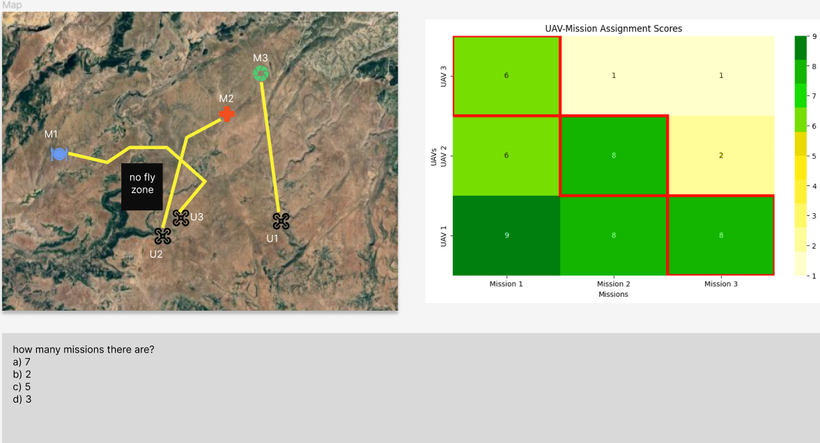

On the first screen (left screen), participants will see a map that moves and changes. This map will show symbols for drones (UAVs) and the tasks they need to do, as well as obstacles like areas the drones cannot fly through. Lines on the map will connect drones to their tasks, showing the routes they should take. The connection between each UAV and mission is based on the system algorithm.
On the second screen (right screen), participants will see different data visualization formats based on the experiment group:

Alphanumeric:
The first group will be provided with a traditional table layout containing raw data metrics related to both UAVs and missions. This data includes (but is not limited to) UAV availability, mission priority, distance, payload capacity, and other relevant operational parameters.
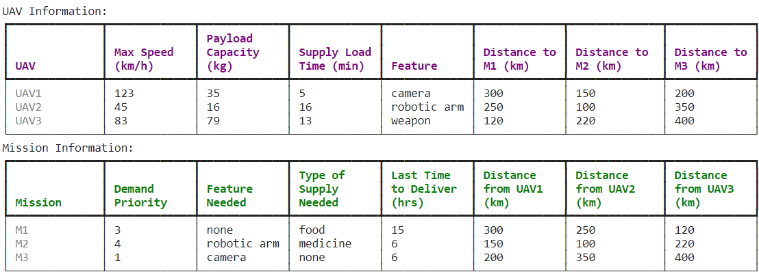

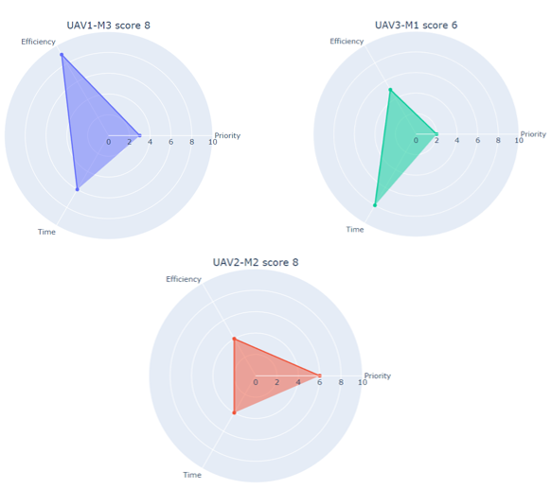
Radar chart:
The second group will be provided with a more graphical representation of data in the form of radar charts. These charts will turn raw data into three key utility features, upon which the UAV-mission assignment score is calculated by the system.

Heatmap:
The third group will be presented with a heatmap that graphically represents the algorithm's scoring system. In this visual representation, the participant will be able to see all scores between each UAV-mission and the assignment that the algorithm chose based on these scores.
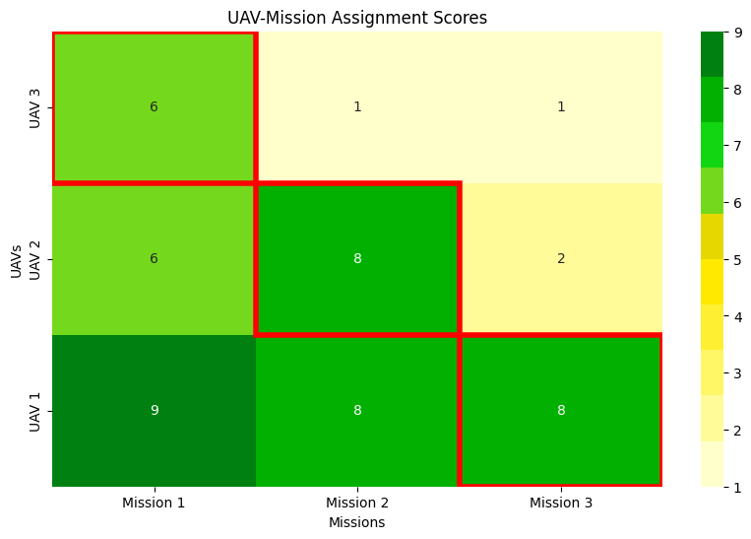
On the bottom of the screen, the participants will need to answer questions that are relevant to the presented trial and test participants’ understanding.
Functionality:
The simulator will visualize the relevant data on the dual screen according to the trials, the user would be able to hover with the keypad over the icons of the UAV or mission and see a pop window with the raw data, the user could click on a path between a UAV and a mission, and it will highlight the corresponding data from the second screen.
Mission description:
For each mission, we have various attributes such as mission priority, mission needs (camera for example), and more. Similarly, for each UAV we have various attributes such as UAV speed, UAV capacity and so on. Finally, we also have attributes for the combination of a UAV for a mission such as the distance between UAV and mission. To understand a possible assignment of a UAV to a mission, we then look at 3 utilities for each UAV X mission combination. These utilities comprise of different attributes of the UAV and mission as listed above:
- Priority factor – quantifies the importance of a mission.
- Efficiency factor - assesses how effectively a UAV's capacity and features matches the mission's requirements.
- Time factor - evaluates the feasibility of the mission based on the estimated delivery time.
The algorithm calculates an overall utility score between each UAV with a mission based on these 3 utilities. Using utility scores, the system will choose the best assignment between UAV and mission such that the sum of all chosen scores will be maximal.
Procedure:
Participants will arrive at the test lab. They will be briefed on the purpose of the experiment, specifically focusing on the impact of visualization on user trust and understanding in a real-time UAV-mission assignment system. Before any experimental tasks commence, each participant will be requested to sign an informed consent form. This will be followed by a personal detail questionnaire. We will collect demographic data, including age, gender, educational background, and experience with UAV systems or related technologies. Participants will also be questioned about their color vision, with those having color blindness excluded from the study due to the visual nature of the experiment. Participants will be introduced to the UAV-mission assignment system and its fundamental concepts. They will then engage in a 10-minute training session to get familiar with the visual aids used in the experiment, the interface of the system, and the different levels of scenarios. In the next step each of the participants will perform the test trials, the participant will face a trial that will be displayed via the simulator screens. After each trial the participant will be asked to fill in a questionnaire to test his or her understanding and situational awareness. There will be a total of 18 trials that are divided to 3 trials for each block and each participant will face all trials from all blocks. After each block the user will be asked to fill in a trust questionnaire.

Trial Design:
There will be three complexity levels for the experimental trial:
- Beginner trial:
  - UAVs: 2
  - Missions: 2
- Intermediate trial:
  - UAVs: 4
  - Missions: 4
- Advanced trial:
  - UAVs: 8
  - Missions: 8
Two levels of RoS
- High - at least 90% of assignments are optimal.
- Low - at most 50% of assignments are optimal.
6 different sets of trials (each trial will take up to 2 minutes):
- Each UAV has one different high-score mission to assign to.
- At least half of the UAVs have more than 1 mission with high score so UAVs have overlap on missions they can be assigned to.
- One of the UAVs can make only a specific mission which will make another UAV to be assigned to a low score assignment.
- One of the UAVs can make only a specific mission which will cause the system to exclude this UAV and this specific mission.
- Dynamic change in mission priority.
- Dynamic change in UAV capability.

Estimated Participant Timeline for Experiment Participation:
- inclusive of instructions: 15 minutes
- training: 10 minutes
- execution of trials: 36 minutes
- breaks (3 minutes after every 2 blocks): 9 minutes
- Total Estimated Time: 70 minutes
Data analysis:
- Compare the responses of the control group and the test group using appropriate statistical tests (e.g., t-test or ANOVA).
- Examine the difference in means and look for statistical significance.

Research Plan
Months 1-4: Literature review and refining research questions.
Months 5-6: Designing visualizations for real time XAI explanation.
Months 6-7: Design experiments and start data collection.
Months 7-8: Finalize data collection, conduct data analysis.
Months 9-10: Analyze initial findings, refine/redesign visualization, collect and analyze new data.
Months 11-12: Drafting and refining research paper.
Month 13: Presentation of preliminary findings at seminars/conferences.
Month 14: Finalize and submit the research paper for publication.

Initial Results
So far, I have completed a thorough review of relevant literature, detailed in sections 2 and 3.
A crucial discovery from this review is the importance of creating visualizations that are straightforward and user-friendly. These visualizations should closely align with both the system's functionality and the user's needs. Based on these insights, I have developed the visualizations presented in section 5, ensuring they are intuitive and effectively serve the intended purpose.

Research Contribution
This research underscores the potential of visual aids as a pivotal tool to enhance Situation Awareness, user understanding and trust in real-time decision-making system. It will contribute to many areas like healthcare, driving, or any place where the system-based AI make real time decisions.

Reference
- Adadi, A., & Berrada, M. (2018). Peeking inside the black-box: a survey on explainable artificial intelligence (XAI). IEEE Access, 6, 52138-52160.
- Ali, S., Abuhmed, T., El-Sappagh, S., Muhammad, K., Alonso-Moral, J. M., Confalonieri, R., Guidotti, R., Del Ser, J., Díaz-Rodríguez, N., & Herrera, F. (2023). Explainable Artificial Intelligence (XAI): What we know and what is left to attain Trustworthy Artificial Intelligence. Information Fusion, 99, 101805.
- Anders, C. J., Weber, L., Neumann, D., Samek, W., Müller, K.-R., & Lapuschkin, S. (2022). Finding and removing Clever Hans: using explanation methods to debug and improve deep models. Information Fusion, 77, 261-295.
- Arrieta, A. B., Díaz-Rodríguez, N., Del Ser, J., Bennetot, A., Tabik, S., Barbado, A., García, S., Gil-López, S., Molina, D., & Benjamins, R. (2020). Explainable Artificial Intelligence (XAI): Concepts, taxonomies, opportunities and challenges toward responsible AI. Information Fusion, 58, 82-115.
- Arya, V., Bellamy, R. K., Chen, P.-Y., Dhurandhar, A., Hind, M., Hoffman, S. C., Houde, S., Liao, Q. V., Luss, R., & Mojsilović, A. (2021). AI Explainability 360 Toolkit. Proceedings of the 3rd ACM India Joint International Conference on Data Science & Management of Data (8th ACM IKDD CODS & 26th COMAD),
- Azevedo-Sa, H., Jayaraman, S. K., Esterwood, C. T., Yang, X. J., Robert Jr, L. P., & Tilbury, D. M. (2021). Real-time estimation of drivers’ trust in automated driving systems. International Journal of Social Robotics, 13(8), 1911-1927.
- Biros, D. P., Fields, G., & Gunsch, G. (2003). The effect of external safeguards on human-information system trust in an information warfare environment. 36th Annual Hawaii International Conference on System Sciences, 2003. Proceedings of the,
- Bussone, A., Stumpf, S., & O'Sullivan, D. (2015). The role of explanations on trust and reliance in clinical decision support systems. 2015 international conference on healthcare informatics,
- Chazette, L., & Schneider, K. (2020). Explainability as a non-functional requirement: challenges and recommendations. Requirements Engineering, 25(4), 493-514.
- Daronnat, S., Azzopardi, L., Halvey, M., & Dubiel, M. (2021). Inferring Trust From Users' Behaviours; Agents' Predictability Positively Affects Trust, Task Performance and Cognitive Load in Human-Agent Real-Time Collaboration. Front Robot AI, 8, 642201. https://doi.org/10.3389/frobt.2021.642201
- Drnec, K., Marathe, A. R., Lukos, J. R., & Metcalfe, J. S. (2016). From Trust in Automation to Decision Neuroscience: Applying Cognitive Neuroscience Methods to Understand and Improve Interaction Decisions Involved in Human Automation Interaction. Front Hum Neurosci, 10, 290. https://doi.org/10.3389/fnhum.2016.00290
- Du, D., Zhang, C., Song, Y., Zhou, H., Li, X., Fei, M., & Li, W. (2019). Real-time H∞ control of networked inverted pendulum visual servo systems. IEEE transactions on Cybernetics, 50(12), 5113-5126.
- Dwivedi, R., Dave, D., Naik, H., Singhal, S., Omer, R., Patel, P., Qian, B., Wen, Z., Shah, T., & Morgan, G. (2023). Explainable AI (XAI): Core ideas, techniques, and solutions. ACM Computing Surveys, 55(9), 1-33.
- Endsley, M. R. (2017). Direct measurement of situation awareness: Validity and use of SAGAT. In Situational awareness (pp. 129-156). Routledge.
- Endsley, M. R. (1995). Measurement of situation awareness in dynamic systems. Human factors, 37(1), 65-84.
- Endsley, M. R. (2015). Situation awareness misconceptions and misunderstandings. Journal of cognitive Engineering and Decision making, 9(1), 4-32.
- Endsley, M. R., & Kiris, E. O. (1995). The out-of-the-loop performance problem and level of control in automation. Human factors, 37(2), 381-394.
- Ferreira, G., Alves, P., & de Almeida, S. (2021). Platform for real-time data analysis and visualization based on Big Data methods. 2021 16th Iberian Conference on Information Systems and Technologies (CISTI),
- Fjeld, J., Achten, N., Hilligoss, H., Nagy, A., & Srikumar, M. (2020). Principled Artificial Intelligence: Mapping Consensus in Ethical and Rights-Based Approaches to Principles for AI (SSRN Scholarly Paper ID 3518482). Social Science Research Network, Rochester, NY.
- Guidotti, R., Monreale, A., Ruggieri, S., Turini, F., Giannotti, F., & Pedreschi, D. (2018). A survey of methods for explaining black box models. ACM computing surveys (CSUR), 51(5), 1-42.
- Guleria, P., Naga Srinivasu, P., Ahmed, S., Almusallam, N., & Alarfaj, F. K. (2022). XAI framework for cardiovascular disease prediction using classification techniques. Electronics, 11(24), 4086.
- Gutzwiller, R. S., Chiou, E. K., Craig, S. D., Lewis, C. M., Lematta, G. J., & Hsiung, C.-P. (2019). Positive bias in the ‘Trust in Automated Systems Survey’? An examination of the Jian et al. (2000) scale. Proceedings of the Human Factors and Ergonomics Society annual meeting,
- Hergeth, S., Lorenz, L., Vilimek, R., & Krems, J. F. (2016). Keep your scanners peeled: Gaze behavior as a measure of automation trust during highly automated driving. Human factors, 58(3), 509-519.
- Hoffman, R. R., Mueller, S. T., Klein, G., & Litman, J. (2018). Metrics for explainable AI: Challenges and prospects. arXiv preprint arXiv:1812.04608.
- Hudon, A., Demazure, T., Karran, A., Léger, P.-M., & Sénécal, S. (2021). Explainable artificial intelligence (XAI): how the visualization of AI predictions affects user cognitive load and confidence. Information Systems and Neuroscience: NeuroIS Retreat 2021,
- Jacovi, A., Marasović, A., Miller, T., & Goldberg, Y. (2021). Formalizing trust in artificial intelligence: Prerequisites, causes and goals of human trust in AI. Proceedings of the 2021 ACM conference on fairness, accountability, and transparency,
- Jian, J.-Y., Bisantz, A. M., & Drury, C. G. (2000). Foundations for an empirically determined scale of trust in automated systems. International journal of cognitive ergonomics, 4(1), 53-71.
- Kaur, D., Uslu, S., & Durresi, A. (2021). Requirements for trustworthy artificial intelligence–a review. Advances in Networked-Based Information Systems: The 23rd International Conference on Network-Based Information Systems (NBiS-2020) 23,
- Kawakura, S., Hirafuji, M., Ninomiya, S., & Shibasaki, R. (2022). Analyses of diverse agricultural worker data with explainable artificial intelligence: Xai based on shap, lime, and lightgbm. European Journal of Agriculture and Food Sciences, 4(6), 11-19.
- Laplante, P. A. (2004). Real-time systems design and analysis (p. xxi). New York: Wiley.
- Laato, S., Tiainen, M., Najmul Islam, A., & Mäntymäki, M. (2022). How to explain AI systems to end users: a systematic literature review and research agenda. Internet Research, 32(7), 1-31.
- Langer, M., Oster, D., Speith, T., Hermanns, H., Kästner, L., Schmidt, E., Sesing, A., & Baum, K. (2021). What do we want from Explainable Artificial Intelligence (XAI)?–A stakeholder perspective on XAI and a conceptual model guiding interdisciplinary XAI research. Artificial Intelligence, 296, 103473.
- Liu, J., Akash, K., Misu, T., & Wu, X. (2021). Clustering human trust dynamics for customized real-time prediction. 2021 ieee international intelligent transportation systems conference (ITSC),
- Madsen, M., & Gregor, S. (2000). Measuring human-computer trust. 11th australasian conference on information systems,
- Mankodiya, H., Jadav, D., Gupta, R., Tanwar, S., Alharbi, A., Tolba, A., Neagu, B.-C., & Raboaca, M. S. (2022). XAI-Fall: Explainable AI for Fall Detection on Wearable Devices Using Sequence Models and XAI Techniques. Mathematics, 10(12), 1990.
- Muir, B. M. (1994). Trust in automation: Part I. Theoretical issues in the study of trust and human intervention in automated systems. Ergonomics, 37(11), 1905-1922.
- Muir, B. M., & Moray, N. (1996). Trust in automation. Part II. Experimental studies of trust and human intervention in a process control simulation. Ergonomics, 39(3), 429-460. https://doi.org/10.1080/00140139608964474
- Nori, H., Jenkins, S., Koch, P., & Caruana, R. (2019). Interpretml: A unified framework for machine learning interpretability. arXiv preprint arXiv:1909.09223.
- Rees, C., & Müller, B. (2022). All that glitters is not gold: trustworthy and ethical AI principles. AI and Ethics, 1-14.
- Russell, S. J., & Norvig, P. (2010). Artificial intelligence a modern approach. London.
- Sanneman, L., & Shah, J. A. (2020). A situation awareness-based framework for design and evaluation of explainable AI. In Explainable, Transparent Autonomous Agents and Multi-Agent Systems: Second International Workshop, EXTRAAMAS 2020, Auckland, New Zealand, May 9–13, 2020, Revised Selected Papers 2 (pp. 94-110). Springer International Publishing.
- Schrills, T., & Franke, T. (2020). Color for characters-effects of visual explanations of AI on trust and observability. Artificial Intelligence in HCI: First International Conference, AI-HCI 2020, Held as Part of the 22nd HCI International Conference, HCII 2020, Copenhagen, Denmark, July 19–24, 2020, Proceedings 22,
- Schulze-Weddige, S., & Zylowski, T. (2021). User Study on the Effects Explainable AI Visualizations on Non-experts. International Conference on ArtsIT, Interactivity and Game Creation,
- Shneiderman, B. (2020). Bridging the gap between ethics and practice: guidelines for reliable, safe, and trustworthy human-centered AI systems. ACM Transactions on Interactive Intelligent Systems (TiiS), 10(4), 1-31.
- Snyder, H. (2019). Literature review as a research methodology: An overview and
- Stefik, M., Youngblood, M., Pirolli, P., Lebiere, C., Thomson, R., Price, R., Nelson, L. D., Krivacic, R., Le, J., & Mitsopoulos, K. (2021). Explaining autonomous drones: An XAI journey. Applied AI Letters, 2(4), e54.
- Tjoa, E., & Guan, C. (2020). A survey on explainable artificial intelligence (xai): Toward medical xai. IEEE transactions on neural networks and learning systems, 32(11), 4793-4813.
- von Eschenbach, W. J. (2021). Transparency and the black box problem: Why we do not trust AI. Philosophy & Technology, 34(4), 1607-1622.
- Wallach, D. P., Flohr, L. A., & Kaltenhauser, A. (2020). Beyond the buzzwords: On the perspective of ai in ux and vice versa. International Conference on human-computer interaction.
- Ware, C. (2019). Information visualization: perception for design. Morgan Kaufmann.

